DEPARTMENT OF COMMERCE, SGA GDC YELLAMANCHILI
DISTRIBUTION OF FOOD TO HUNGERS THROUGH GURAJADA SERVICE FOUNDATION ON 02.11.2021

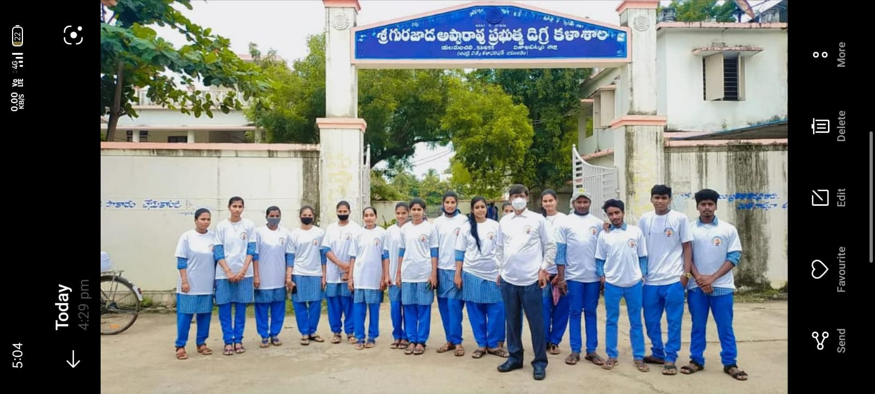

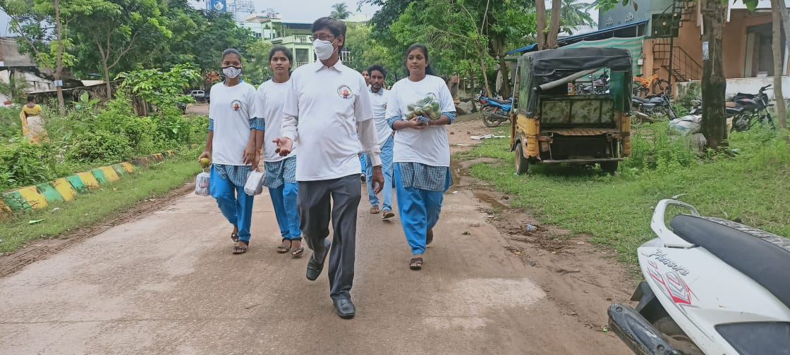

DEPARTMENT OF COMMERCE, SGA GDC YELLAMANCHILI
SERVING FOOD TO HUNGERS THROUGH GURAJADA SERVICE FOUNDATION ON 02.11.2021
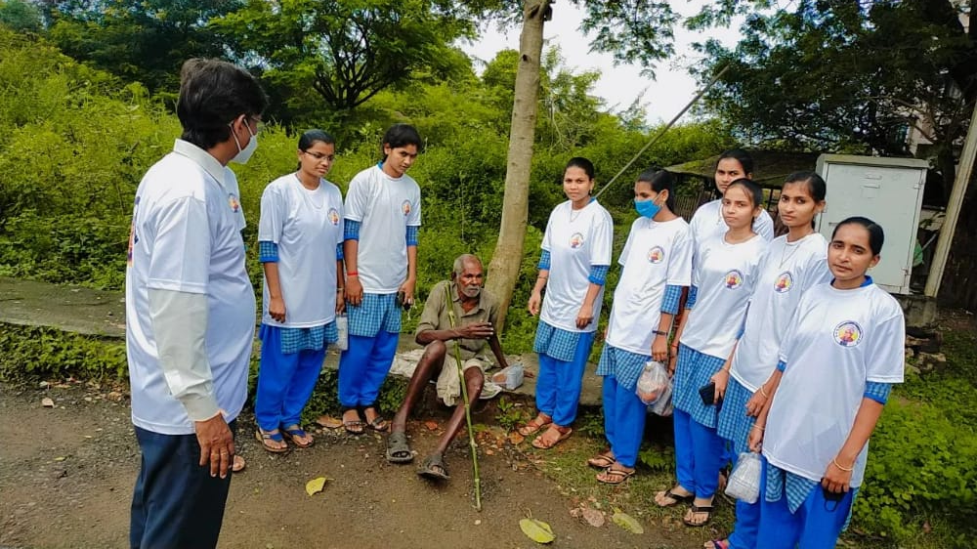
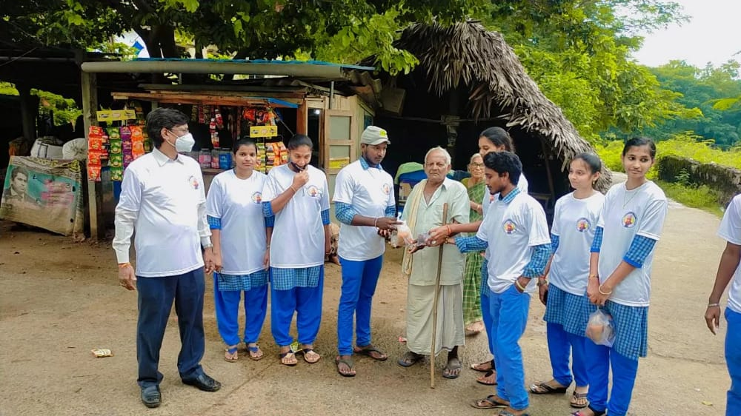

DEPARTMENT OF COMMERCE, SGA GDC YELLAMANCHILI
SERVING FOOD TO HUNGERS THROUGH GURAJADA SERVICE FOUNDATION ON 02.11.2021
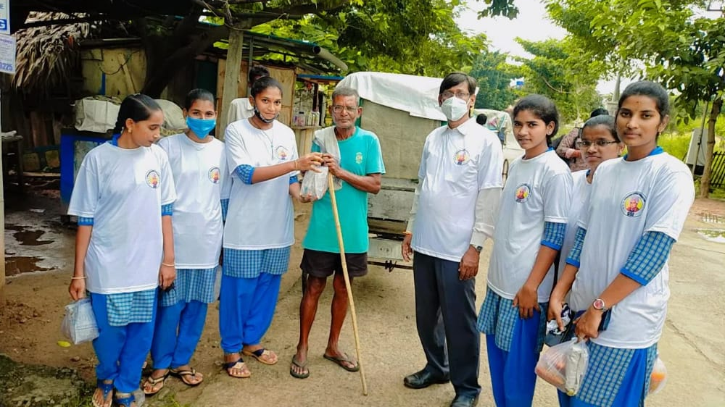

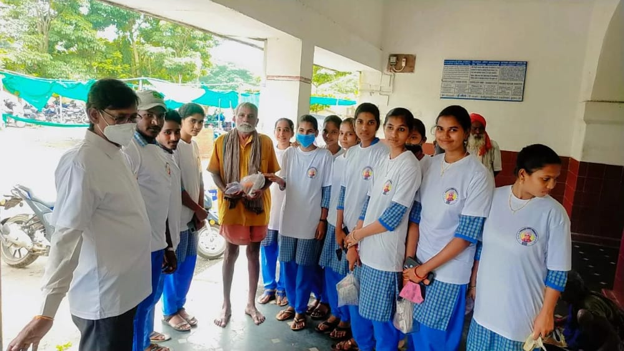

CELEBRATION OF 4TH GSF FOUNDATION DAY
ON 02.1.22 AT SGA GDC, YELLAMANCHILI
